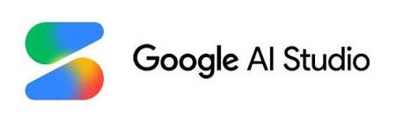
INTRODUCTION
Google AI Studio is Google's web-based platform for building and testing applications using Gemini AI models. It offers a simple interface for prompt engineering, API testing, and AI experimentation without complex setup.

SOFTWARE REVIEW
Google
AI Studio
A Powerful Platform for Building with Gemini AI

★★★★⯪
4.8/5
Excellent

KEY FEATURES

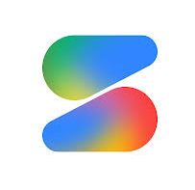
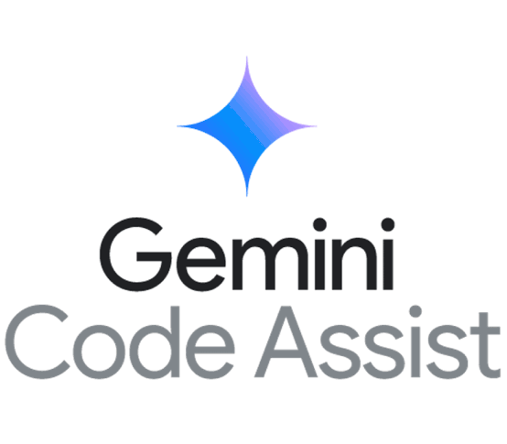

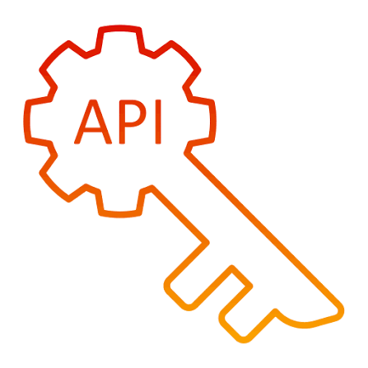
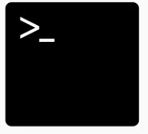


Gemini Models
Access Google's latest Gemini AI models.

Code Assistance
Generate, explain, and debug code.

Multimodal Support
Work with text, images, audio, and code.
.

API Integration
Generate API keys and connect applications.
.

Prompt Playground
Test and refine prompts instantly.
.

USER INTERFACE

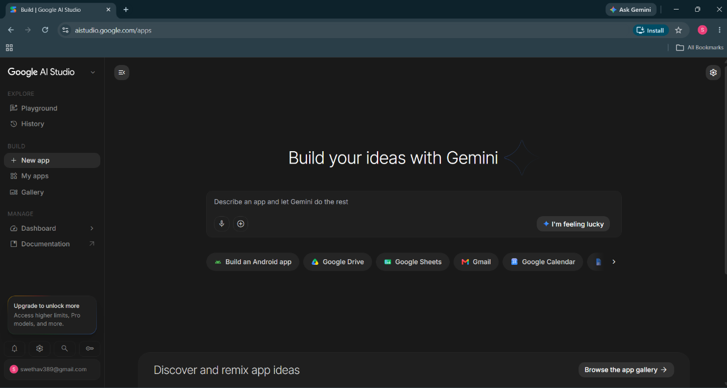

✔ Clean and modern design
✔ Easy navigation
✔ Beginner-friendly interface
✔ Fast prompt testing

Reviewed by: Swetha
July, 14, 2026



PERFORMANCE
Response Quality ★★★★★

Speed ★★★★★

Reliability ★★★★☆

Ease of Use ★★★★★

Overall Performance ★★★★☆ 4.8/5

The models deliver fast, accurate, and context - aware responses across a veriety of tasks.
AT A GLANCE
Product
Google Ai Studio
Developer
Google
Platform
Web
Best For
Developers, Students, Researchers
Pricing
Free To Start

CONS
❌ Internet required
❌ Free usage limits
❌ Advanced features may require paid access
❌ Limited offline functionality

PROS
✅ Free to use
✅ Easy API integration
✅ Powerful Gemini models
✅ Fast AI responses
✅ Beginner friendly

★★★★⯪ 4.8/5

OVERALL RATING

FINAL VERDICT
Google AI Studio is an excellent platform for exploring Google's Gemini models. Its intuitive interface, fast performance, and developer-friendly tools make it a great choice for learning, prototyping, and building AI-powered applications.
Google AI Studio makes AI development simple, accessible, and efficient for both beginners and professionals.

